**North South University**

**Department of Electrical & Computer Engineering**

**Junior Project Proposal Report**

**Title of the Project :** Create your own identity

# Group: 4

# Name and IDs of the students:

1.Shawon Das 1712591642

2.Smita Roy Jyoti 1711615042

**Faculty’s Name:** Intisar Tahmid Naheen (Itn)

Submission Date : 26-07-2020

**Table of Contents**

Topic Page

1. Abstract 3
2. Keywords 3
3. Introduction and Background 4
4. Objectives 5
5. Scopes 5
6. Use Case Diagram 6
7. Methodology 7
8. Software Use 8
9. Problems 9
10. Constrains 9

**Abstract:**

This is an android application. The name of our project is Deal With Home Made goods and Foods. The project is intended where customers can select items they want to buy, add them to their carts and finally check out the cart when they are ready to purchase them.

This application is basically for the students and the home maker who want to earn through online without going outside.

Students and the other who want to be self independent can use this app. They can sell homemade goods and foods through this app. This in not full time job and there is no risk of losses because they will use their free time for their little business. Students also can find tuition from this app.

On the other hand the people who want to but home made products they can buy the genuine home made goods and foods from this app. Think, they will be satisfied.

**Keywords**:

Admin , Customers, Log In , Registration , Add product, Display Product , Add to Cart, Pay Bill , Exit.

# Introduction and Background:

This App is like online selling and shopping apps. Now a days there are many online shopping apps, like Amazon, Aliexpress, Daraz, Evaly, shop up etc. They basically sell the branded products ,local market products and many necessary products but our main aim is to help the students and homemakers. We decided , in this app we only buy and sell home made products, foods etc. By this app people can earn money by sell their interests and hand made products. For example :

One can paint or can draw pictures well. If she/he want to sell that painting she/he can post their painted pictures photo for sell with proper price through our app and from there one can buy that product and can decorate their home. Like this someone have interest on cooking, they can make a sell post for their home made hygienic foods, like this one can make pickle, one can make dress, one can make homemade beauty products, bags, footwear , one can sell vegetables, fruits or flower seeds etc through our app. Students also can send post for being a tutor and those who need tutor they can hire them by proper requirements.

We think if we can make this app it will be very much beneficial to the general peoples, Homemakers and specially for the students and those who want to use home made products.

It will also help the women who can not go outside but want to be self independent.

# Objectives:

The objectives of this project/thesis are to…..

1. Help the students, the homemaker and the neglected women who need to be self independent.
2. Help those who want authentic homemade products and hygienic foods. Etc.

# Scope:

1. Our android application is an interface between the customers and the Admin dealing with homemade products.
2. We think if we can spread our apps among the peoples it will help to reduce unemployment problem a lot.
3. By the help of this app student other people will able to self independent Customer will be helpful by genuine home made products.

**Use Case Diagram:**

Its not our final diagram. We actually discuss it among us and make this demo diagram.

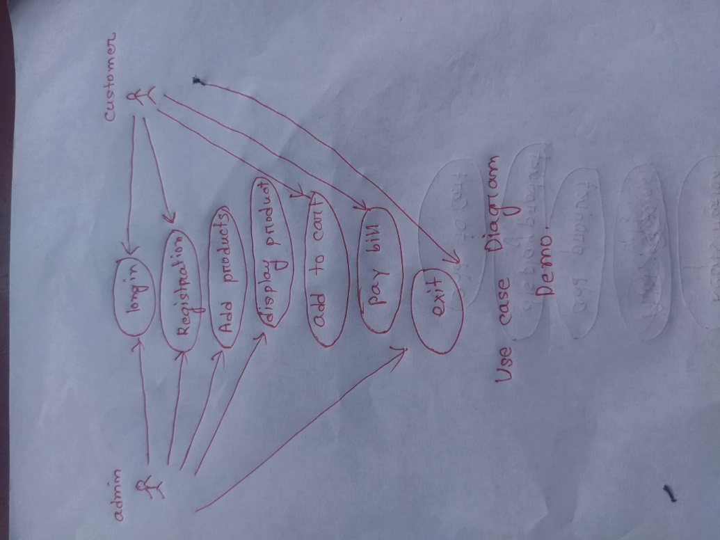

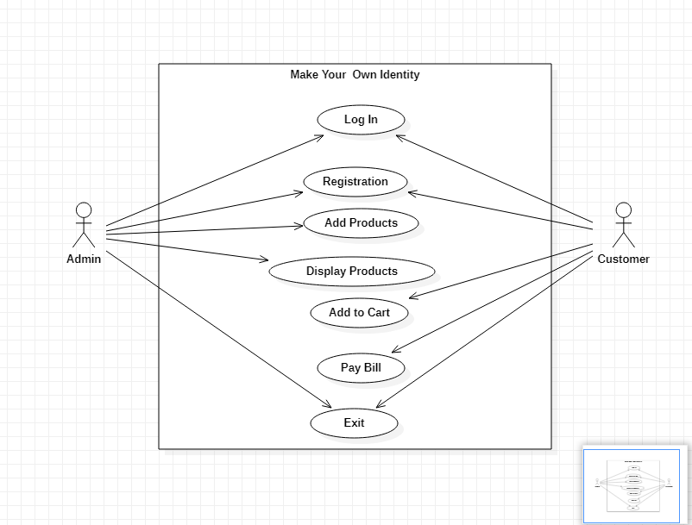

**Methodology :**

Admin : They can send selling post for their products.

Customers: They can see the sell post and make choice from them. They can search their product category. They can add product to cart and make online payment.

Registration: Every one have to sign up for access the app with proper details and set a password.

Log in : for access this app first need to log in by their id and password.

Add Products: Admin can add products.

Display Products:Admin can display products.

Add to Cart : Customers can view all the product and can able to add the product in carts.

Pay Bill :Customers can pay bill online .

Exit : Both customers and Admins can easily exit the app by pressing exit button.

# Software Used:

We decide to use android studio for the app development and for code we will use java programming language jdk and for database we wil use firebase.

**Problems:**

Our android app can face some problem. Like what will be the delivery system, ,will it be by curior or by man. We will try to clear the delivery system.

Many customer can face problem in payment. There will be option for online payment only. But if some one cancel their order after payment , there is no option for return. But we have to fix the problem.

**Constrains :**

we need to add the genuine customers and sellers by verification. Otherwise fake frod peoples can distort our interface technical challenges and uncertainties

Some times may occurs server problem, for that peoples can fail to log in or sign up. They may also faced problem in online transaction. These are our technical challenges and uncertainties. We should always try to overcome those.